Essex Blind Charity
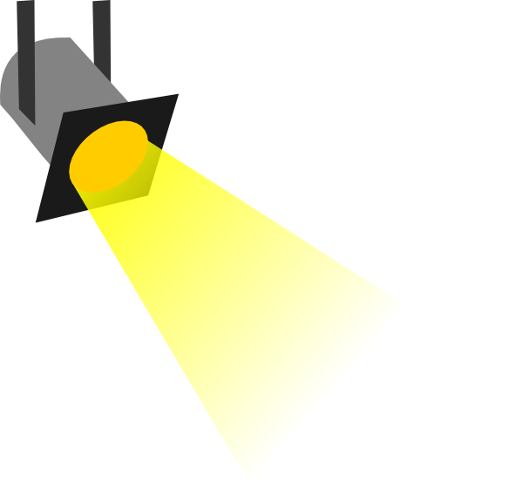
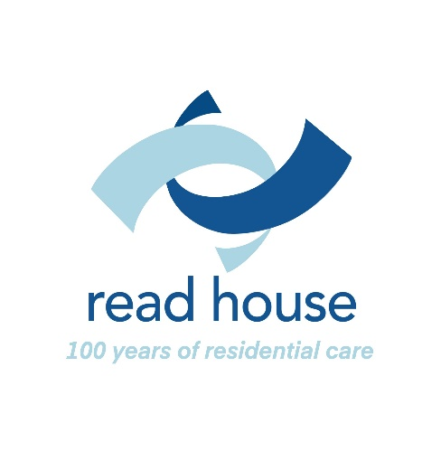

Spotlight
December/January 2021-22

ISSUE 105

Contents:

Editorial page 3
Community Support Team page 4
News and Products page 6
Quiz page 7
Technology page 8
Entertainment page 9
Spotlight On page 10
Answers to Quiz page 11

Please send your articles for inclusion in Spotlight to:

The Editor
Essex Sight
40 Osborne Street
Colchester
CO2 7DB
01206 548196
Email: services@essexsight.org.uk

Items for the next issue should reach the Editor by 4th March

The Editor writes:

Merry Christmas and a Happy New Year to you all. Just as things were starting to head towards some sort of normality, we are once again having to take precautions and that has influenced this issue. Many of the usual festive activities that get reported do not seem to be happening and with no other contributions, this has turned out to be one of our thinnest issues to date! Next year Spotlight will have to return to a quarterly publication unless we get a significant increase in contributions.

We hope you will find the articles informative and of interest. Please feel free to share Spotlight with other visually impaired people and their carers. Everyone who is newly registered in Essex will receive a copy of Spotlight and they can request their own copy in large print format, memory stick or by email. Unfortunately, we are unable to provide copies in Braille or on cassette.
I hope you will all continue to send your contributions, as your stories and experiences make Spotlight of interest to everyone. You can email articles to services@essexsight.org.uk

Editor
Community Support Team by Jonathan Dixon

The community team are as ever, busy with home visits and referrals but they are there to support you, so please get in touch if you would like some information, support, or guidance.

Lost in space?
I hope that I may be able to explain why some of the readers/listeners did not receive their copy of Spotlight and I am sincerely hoping that you have got this one! The main Royal Mail depot in Chelmsford has a backlog affecting postcodes CM1, CM2 and CM3. This has not only affected the postage of mail but has also caused a huge delay for Chelmsford and District Talking Newspapers in being able to distribute the recorded version of Spotlight. The reason being that 150 usb sticks and their pouches are missing somewhere in the Depot! Pat Wilson from Chelmsford and District Talking Newspapers called to let us know that she had been to the depot given them what for! And too rightly, I say, as Royal Mail are letting you all down. Here’s hoping that they manage to get it sorted for this issue!
Reaching Out At Christmas (ROAC)
If you are a Wivenhoe resident and facing Christmas alone, the ROAC Committee would welcome you to a scrumptious festive lunch, convivial company, musical entertainment, and a raffle prize - everyone a winner! The event is fully accessible, the community bus is available for anyone who needs transport, and carers are welcome. If you are interested in attending, or would like further information, please ring Glynis on 07904 397605 before the closing date of December 13th.
Guests will be asked to arrive at the William Loveless Hall (WLH) from 12.30 onwards for lunch at 1pm; those who have asked for transport will be picked up the Community Bus at any time from 11.30 am onwards. All guests will be contacted by phone a week before Christmas to confirm attendance and arrangements.

Brian Beveridge

I am sad to report that Brian Beveridge, one of the Charity’s former Trustees passed away on 12th November. Brian was initially invited as a professional advisor to the Board of Trustees by the Chair, Lady Dorothy Read when the Charity operated as the Essex Voluntary Association for the Blind, before eventually becoming a trustee.
Although a proud Irishman and Dubliner, Brian already had an affinity with the County having spent some of his childhood in Colchester. Brian was a highly regarded consultant who was made a Fellow of the Royal College of Ophthalmologists in 1989, which is the highest accolade that the college can bestow, recognizing individuals who have made a significant contribution to ophthalmology.
Brian helped a countless number of people with sight loss problems on a personal level, spending time in developing countries providing his services to those desperately in need. He was always so willing to offer sound advice on his subject, being co-opted onto many committees including the Essex Local Optical Committee.
As a Trustee, Brian was a champion for our community services, recognizing the need early on for support to be given to people in the community and his contributions were always insightful and knowledgeable.
Brian was a real gentleman, polite, respectful but with a fabulously dry sense of humor. I did not personally know Brian, but I know that the Charity gained hugely from his support over the years. The trustees and those who did know him will truly miss him.

News and Products

Disabled Parking Badge
Essex County Council have volunteers who will contact the client at a set time and date and help complete the new 45-page form over the phone.
Contact 0345 6037630
Professional Vision Drop in Day
Giles from Professional Vision Services will be attending Colchester Sight Centre for a drop-in day, demonstrating their magnifying products on 14th February 2022. Professional Vision have been supplying magnifying equipment for over 30 years and have a range of equipment suitable for use at home or while you are out and about. If you are unable to attend, Giles is happy to arrange a home visit.
Contact 01462 420751
Job Opportunity
ARX Vision is a company developing a smartphone app which uses artificial intelligence to interpret visual information through scene detection, object, face and text recognition, along similar lines to the EnVision and Seeing AI apps which you may have come across. The aim of this app though is to be much more affordable than the ones which use bespoke glasses, and at the moment it runs on Android.
ARX Vision is looking for a freelance product manager to do user testing from a sight-impaired person's point of view, connect with other users and help develop the product. Further details, including how to apply, are here:
https://arx.vision/pages/careers
The contact is Charles Leclercq on charles@arx.vision.
Quiz

General knowledge and a few festive teasers thrown in.

- How many ghosts are there in “A Christmas Carol?”
- In which country did eggnog originate?
- In which Christmas move does Tom Hanks play six of the characters?
- What song is played at the end of the 1988 film “Die Hard?”
- What is the opening line to Shakin’Stevens’ “Merry Christmas Everyone?”
- What is traditionally hidden inside a Christmas pudding?
- What colour are mistletoe berries?
- What is the Grinch’s dog called?
- In which modern-day country was St. Nicholas born?
- In which part of your body would you find the cruciate ligament?
- What is the name of the 1976 film about the Watergate scandal?
- Which tennis grand slam is played on a clay surface?
- What was the old name for a Snickers bar before 1990?
- Street artist Banksy is originally associated with which British city?
- What is the full postcode of the Houses of Parliament?
- John Denver’s “Take Me Home Country Roads” is about which US state?
- What is the first line of Queen’s “Bohemian Rhapsody?”

Technology

Moorfields Eye Hospital to use AI to analyse retinal images
A new research project will use artificial intelligence (AI) to analyze the retinal images of diabetes patients to detect potentially sight-threatening eye disease as reported by Optometry Today, 31 October 2021.
The £500,000 initiative will be led by Moorfields Eye Hospital NHS Foundation Trust and St George’s, University of London, with funding from NHSX and the Health Foundation.
The study could potentially provide evidence to support the commissioning and deployment of the first widespread use of AI within the NHS. There are possible applications within the NHS Diabetic Eye Screening Program (DESP), which generates millions of retinal images each year.
Researchers will focus on ensuring that the technology has safeguarding systems and that AI performance does not vary across population sub-groups, such as ethnicity and gender.
The scientists will create a database of retinal images from different ethnic groups, genders and ages to ensure that anyone with diabetes can benefit from the technology.
Consultant ophthalmologist, Professor Adnan Tufail, highlighted the importance of ensuring that the first widespread deployment of AI within the NHS is safe and performs at a high level across the board.

RNIB launches braille keyboard
The RNIB has launched a pocket-friendly wireless braille keyboard that can be used to navigate mobile phones and tablets via Bluetooth. The Hable One, requires no installation and was called ‘easy to use’ by the RNIB.
It is available from the RNIB shop for £286.80

Entertainment

Its Panto season again. Oh, no it isn’t, oh, yes, it is! Here’s a list of audio described performances in our area:
London
A Christmas Carol – The Old Vic, 10th December Tel. 0344 871
7635
Jonny Woo’s All Star Christmas Cabaret – Battersea Arts Centre 10th December Tel. 0207 223 2223
The Bolds - Unicorn Theatre 11th December Tel. 0207 645 0560
The Fir Tree – Shakespeare’s Globe, 29th December Tel. 0207 401 9919
Wolf Witch Giant Fairy – Royal Opera House 2nd January Tel. 0207 304 4000
Pantoland at the Palladium – London Palladium 6th January Tel. 0207 087 7747
Colchester
Aladdin - Mercury Theatre, Colchester 8th January Tel. 01206 573948

Vocal Eyes
Experience art and culture through audio description. Bringing theatre, museums, galleries and heritage sites to life for blind and visually impaired people.
For more information or to find out what’s on near you, email: enquiries@vocaleyes.co.uk or telephone 020 7375 1043.

Spotlight On

AbilityNet

In 1987 David Morriss, then an IBM UK director, established in IBM Warwick the Support Centre for People with Disabilities. The Charity’s purpose is to enable a world of digital inclusion by supporting disabled and older people to achieve everything they can at work, in education or at home.
Their goal is to improve lives by recommending suitable technology to function as an enabler for those who need help. This has been particularly relevant in communities and homes during the Covid-19 coronavirus pandemic. They have still managed to provide support during this challenging time whilst following government guidelines on reducing the risk of transmission of the virus.
AbilityNet has approximately 70 staff and 350 IT volunteers providing free services through the ‘IT Can Help programme’ where skilled IT people provide IT support, training and help for disabled and elderly people in their homes across the UK.
They also deliver assessments to disabled people whether they are in work, home or education and work with organisations helping them design, build and deliver accessible on-line systems, services, and products.
These two services complement each other ensuring individuals can use and get the best from their technology and use/access the systems and online services. Close relationships with “big tech” has both supported their work and helped them tap into a global network of like-minded professionals focussed on advancing the digital accessibility agenda.
For more details you can contact their freephone helpline 0800 048 7642 during UK office hours, or email enquiries@abilitynet.org.uk.

Answers to quiz
- Four
- Britain
- The Polar Express
- Let it Snow, Let it Snow, Let it Snow!
- Snow is falling, all around me
- Sixpence
- White
- Max
- Turkey
- Knee
- All the President’s Men
- The French Open
- Marathon
- Bristol
- SW1A 0AA
- West Virginia
- “Is this the real life? Is this just fantasy?”

Contact details
Helpline and office 01206 548196
(Carol Massey, Christine Pratt, Denise Sanders and Steve Massey)
Eye Clinic Liaison Officers 01206 548196
Christine & Denise (Colchester + Tendring hospitals)
Read House 01255 673654
(Tina Cox, Administrator)
Read House is the residential care home run by Essex Blind Charity in Frinton on Sea. The home specialises in the care of elderly people with sight problems. We offer permanent and respite care (short breaks) by staff who have all been trained in visual awareness. The Home is situated on the seafront at Frinton on Sea, a short distance from the town Centre with its friendly local shops.
If you would like to find out more about Read House or receive an Information Pack, please contact Tina.
How you can support us
Essex Blind Charity produces and distributes Spotlight free of charge. However, donations in time or money are always welcome. If you are a UK taxpayer, please consider filling in our gift aid form so we can claim back the tax paid on your donation, thereby allowing us to make even better use of your donation.
If you are writing or redrafting your will please consider leaving us a gift. Your support will enable us to continue to provide and develop the services we provide for people with sight loss throughout Essex. Thank you.
Gift Aid Declaration
On behalf of Essex Blind Charity
Registered Charity No. 1103732
The Gift Aid Scheme enables charities to make more of your donation by reclaiming the tax you have already paid. In order for us to make this claim on your donation(s) please complete this form and return it as soon as possible
Thank you!
Please treat the enclosed gift of £…...............as a Gift Aid donation.
I confirm that I have paid or will pay an amount of Income Tax and/or Capital Gains Tax for the current tax year (6 April to 5 April) that is at least equal to the amount of tax that all charities and Community Amateur Sports Clubs that I donate to will reclaim on my gifts for the current tax year. I understand that other taxes such as VAT and Council Tax do not qualify. I understand the charity will reclaim 25p of tax on every £1 that I have given.
Title……Forename(s)…………………………Surname………………..........
Address………………………………………………………………………………………………………………………………………………………………………..…………..……………………………………………………………………………
Post Code………………………………..
I would like Essex Blind Charity to treat all donations I have made since 1 July 2012 as Gift Aid donations until I notify them otherwise.
Signature……………………………………… Date.................................
Please return your completed form to:
Essex Blind Charity Read House, 23 The Esplanade
Frinton on Sea, Essex CO13 9AU

Are you on our mailing list?
If you are not already on our mailing list for ‘Spotlight’ and would like to receive a regular copy, please complete the form below and return it to Carol Massey at Essex Sight, 40 Osborne Street, Colchester CO2 7DB
Name…………………………………………………………………..
Address……………………………………………………………….……………………………………………………………………………………………………………………………………………………………………………………………………………………………………………………………………………………………………………………………………………………………………………
Tel……………………………………………………………………….

How would you prefer to receive your copy?
Large Print……… Memory Stick………..Email..........................................
We would like to add your contact details to our database so that we may from time to time send you details of developments to our services, events taking place in your area and other information we feel may be of interest to you.
If you would prefer us not to do so, please tick here…………………
We will not pass your details to anyone else without your permission.
You may request us to remove your details from our database at any time.
Useful Telephone Numbers
Colchester Eye Clinic contact numbers
To book or change a NEW appointment only
01206 286870 / 286871 / 286872
To enquire about or change a date for SURGERY only
01206 286874 / 286875
To book or change a FOLLOW UP appointment only
01206 286860 – Mr Sheldrick and Mr Mukherjee
01206 286863 – Mr Patel and Mr Bansal
01206 286856 – Mr Dimitriou
01206 286769 – Mrs Shenoy
For any enquiry relating to Secondary Optometry 01206 286868
For any enquiry relating to Orthoptics 01206 286866
For the EMERGENCY EYE CLINIC only 01206 286882
Please Note self-referrals are not accepted unless the patient is already under our care or has a pink card for the same condition.
Email the department on chu-ftr.ophthalmologydepartment@nhs.net
Broomfields Eye Clinic (Chelmsford)
Appointments - 01245 513900
Diabetic Eye Screening - 01245 516707
Age Related Macular Clinic - 01245 514899
Ophthalmology Surgery waiting list - 01245 514767

Essex Sight Centres
Due to the current restrictions, we are only able to offer a drop-in service at our permanent Resource Centre in Colchester. Please ring to make an appointment.

Colchester Sight Centre
40 Osborne Street
Colchester
CO2 7DB
Open Mon - Fri 10 am to 4 pm,
Saturday 10 – 12pm
Tel: 01206 548196

Maldon Sight Centre
Maldon Library
Carmelite House
White Horse Lane
Maldon CM9 5FW
First Tuesday of each Month
10am – 1pm by appointment only
Tel: 01206 548196
For more information contact Essex Sight Office on 01206 548196.
Email: services@essexsight.co.uk

For information about permanent or respite residential care, contact:
Tina on 01255 673654
Email: info@essexblind.co.uk

