Essex Blind Charity
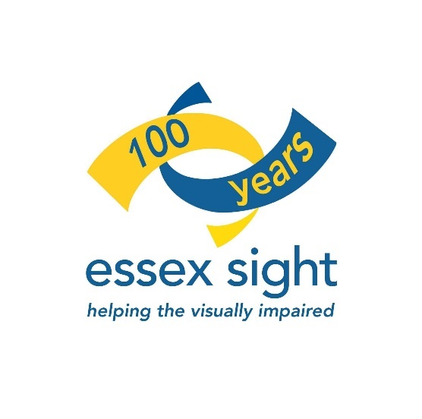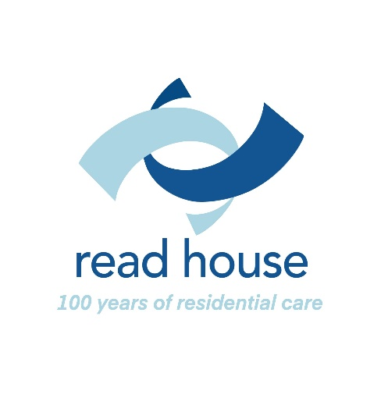
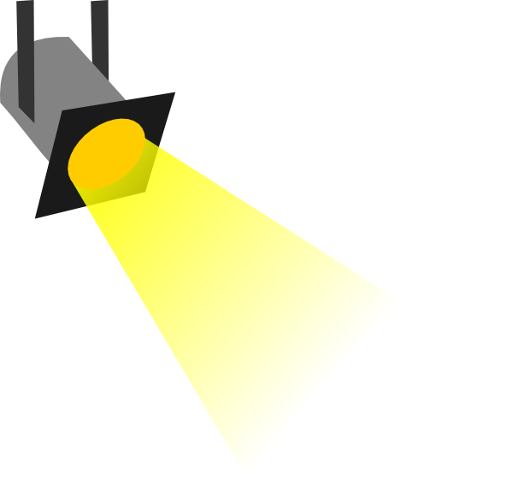

Spotlight
April/May 2021

ISSUE 101

Contents:

Editorial page 3

Community Support Team page 4

News and Products page 6

Quiz page 9

Technology page 10

App, App and Away! page 11

Entertainment page 13

Answers to Quiz page 15

Please send your articles for inclusion in Spotlight to:

The Editor
Essex Sight
40 Osborne Street
Colchester
CO2 7DB
01206 548196
Email: services@essexsight.org.uk

Items for the next issue should reach the Editor by May 3rd

The Editor writes:

Welcome to the April/May edition of our newsletter. Spring is here, the weather is improving and longer, warmer days are coming.

I have no crystal ball, so I won’t make any predictions of when things are going to return to some sort of normality, but at least we have some interesting articles that have been sent in on all manner of products and technology. At a time when many services are still not operating, it is your articles and information, no matter how small, that helps to fill Spotlight and keep it interesting!

We hope you will find the articles informative and of interest. Please feel free to share Spotlight with other visually impaired people and their carers. Everyone who is newly registered in Essex will receive a copy of Spotlight and they can request their own copy in large print format, memory stick or by email. Unfortunately, we are unable to provide copies in Braille or on cassette.

I hope you will all continue to send your contributions, as your stories and experiences make Spotlight of interest to everyone. You can email articles to services@essexsight.org.uk

Editor
Community Support Team by Jonathan Dixon

As I write this, we are still only able to provide telephone and online support, but I hope that changes soon. We have a lot of information crammed into this issue from partners, so I won’t take up too much space, apart from reminding you that if you need assistance, just give the team a ring.

Vaccinations

Are you aged over 55? If you have not had your first dose you should book an appointment on the NHS website or by calling 119.

All Essex-based unpaid carers are being urged to come forward to get their Covid-19 vaccine. If you are aged 16 or over and have not yet been invited for a vaccination, you may be eligible for your first dose.

Visit the NHS website to complete a self-assessment then book your vaccination. Alternatively, you can call 119.

Have your say! Essex goes to the polls

On Thursday 6 May, residents in Essex will go to the polls to have their say on who represents them. Elections for all 75 seats at Essex County Council are taking place. There are also elections for the Essex Police, Fire and Crime Commissioner, many boroughs and districts, and parish councils in some parts of Essex too.

These elections give you the chance to choose who represents you on issues that affect your day-to-day life. If you haven't done so yet, you need to register by 11:59pm on 19th April to vote in the elections on 6th May. You can register to vote on gov.uk, contact your local Electoral Registration Office - GOV.UK (www.gov.uk) or contact your local authority.

Local authorities are working hard to make sure you can cast your vote safely. You will be able to vote at a polling station, or you can register to vote by post or proxy.

The latest on Libraries

Following latest Government guidelines, all libraries remain temporarily closed to the public, except for click and collect which will be possible from Monday 8th March. Some sites (see the list at the bottom of this article) are offering emergency public computer access by appointment only.
Please check individual library opening hours.

The Registration Service and some Blue Badge Assessments that take place from our libraries will continue to operate and have face-to-face appointments. The Mobile Library Service will temporarily be paused. The Home Library Service will continue to operate where possible.

You can book a library computer session online or by ringing the library enquiry line on 0345 603 7628. You will need a permanent library card number to complete your booking. You can still reserve items and, from Monday 8th March, you'll be able to collect these from your chosen library (apart from Springfield Library, which will not be open).

What this means for your library account/loans:
- Items due on or from Monday 4th January will have their loan period extended until Friday 30th April
- Reservations – you will be able to collect these from your chosen library once they become available
While library services are limited, there is still a fantastic range of online resources, including e-books, e-audio, e-comics, newspapers and magazines. If you’re not a library member, you can join online to access these e-resources with an online temporary membership number.

For the latest updates of what’s happening, you can follow Essex Libraries, on Twitter and Facebook and sign up to receive library newsletters

Brentwood, Brightlingsea, Broomfield, Burnham, Chelmsford, Clacton, Coggeshall, Colchester, Frinton, Galleywood, Great Baddow, Greenstead, Halstead, Harlow, Harwich, Hatfield Peverel, Holland, Maldon, North Melbourne, Prettygate, Sible Hedingham, South Woodham Ferrers, Tiptree, Walton, West Clacton, Wickham Bishops and Wivenhoe.

News and Products

Sight Village Online Information Event

Following the success of the Sight Village Online Information Event that took place in January, another online event is happening on Tuesday 20th, Wednesday 21st & Thursday 22nd April.

Sponsored by Sight and Sound Technology, the event will showcase some of the latest technology and offer you up to date information from a selection of regular Sight Village exhibitors. There will be information about person-to-person events that are taking place over the summer and what actions are being put in place to ensure the events are COVID secure.

Once again, this event will take place LIVE via YouTube. Please note: a YouTube account is not required. Like all Sight Village events, this event is FREE to attend however you must register your interest by visiting the Online Information Event Programme, ticking the box next to the sessions that interest you and filling in your details towards the end of the page. This will enable the team to email you with further information about how to access the live stream in the lead up to the event.

At the end of each demonstration there will be time for Q&A therefore if you have any questions you would like exhibitors to answer during the event regarding their products or services, please email in advance to sv@qac.ac.uk

If you have any questions or require further support and assistance with pre-registering please call 0121 803 5484. To help the Sight Village team evaluate expected visitor numbers at their person-to-person events this Summer, they would like to find out your views and invite you to let them know if you are planning to attend an event by completing a short online survey at COVID Secure Person to Person Event Questionnaire (smartsurvey.co.uk)

The Sight Village Team

RNIB Reading Services

RNIB free reading services are available to SSI and SI people, but their website states that the criteria is also for those with a “print impairment disability” - these are people who may have ok visual acuity – but may be live with MS, Parkinson’s (processing problems) arthritis of hands and unable to hold books etc and find reading difficult.

MEDICAL RESEARCH

    - A recent study has found that small increases in air pollution are linked to an increased risk of irreversible sight loss from age-related macular degeneration.

Researchers at UCL found that people living in the most polluted areas were at least eight per cent more likely to report having age-related macular degeneration.

The findings of the long-term study were published in the British Journal of Ophthalmology and used data from 116,000 people in the UK Biobank database aged 40-69 with no eye problems at the start of the study. The health of the retina was examined by scans for more than 50,000 people.

Researchers cannot yet say why air pollution increases the risk of sight loss from age-related macular degeneration but believe it could be because the eyes have a particularly high flow of blood, potentially leaving them vulnerable to the damage caused by tiny particles that are breathed in and then flow around the body.

Professor Paul J Foster from UCL Institute of Ophthalmology led the study. He said: “Here we have identified yet another health risk posed by air pollution, strengthening the evidence that improving the air we breathe should be a key public health priority. Our findings suggest that living in an area with polluted air, particularly fine particulate matter or combustion-related particles that come from road traffic, could contribute to eye disease. Even relatively low exposure to air pollution appears to impact the risk of AMD, suggesting that air pollution is an important modifiable risk factor affecting risk of eye disease for a very large number of people.”

RNIB Book Translation Service

Following from the article posted in the last edition, Fiona Langstone now gives us an update. Over to you Fiona:-

‘I am just listening to Spotlight on memory stick and heard my name mentioned as having received the book from the RNIB translation service. I said I would update people on the recording service as I had not listened to it at the time. So here goes the update.
The translated book was supplied on three discs and at the start of each disk was the title of the book with the author, and the number of the disk, so you know you were putting the right part of the book on. It was extremely helpful because sometimes you can put a disc in and not really know what you were listening to.
The sound quality was very good and the people reading it were clear and understandable. Every word that was printed in the book was spoken and there was nothing left out or altered, as is sometimes the case. There was even part of the book when it must indicate that the author is singing because they sung those particular parts, which was very good and funny. It really made me have appreciation of the book as I am a dedicated fan of the author and due to the RNIB translation service was not made to feel left out. I felt like I was reading along with a sighted person except, of course, I was listening to it.
I would like to thank everybody for their help in informing me of how to get this done and can fully recommend the service as being extremely good. If you have a book you would like to have translated, you can send it along, free of charge, and state the format you require, either large print braille or audio. The only things that they will not translate are items from the council or medical things, as these should be able to be done by the people who sent them. You can have one book done per year. I am not sure whether it applies the same to written correspondence, but I would definitely think of contacting them to find out. Like I have already said, I would totally recommend the service and hope that many other people in my situation will try it out.

Quiz

To get you in the mood for Spring, put a spring in your step with this Musicals quiz, just guess the missing word from the title!

- EASTER ….
- THE LION ....
- BAD .…
- BEAUTY AND THE .…
- BEDKNOBS AND ….
- BILLY ….
- BLOOD ….
- BOOGIE .…
- BREAKFAST AT ….
- BUGSY ….
- THE WIZARD OF ….
- MY FAIR ….
- MEET ME IN ST. …..
- A STAR IS ….
- A LITTLE NIGHT …..
- FUNNY ….
- HELLO ….
- PAINT YOUR ….
- SWEET ….
- FINIAN’S ….
Technology

    - RealSAM, the company behind the In Your Pocket phone, have developed another first. The RealSAM Smart Speaker Subscription for Google Home devices is now available! This is the first dedicated content hub for blind and partially sighted people on smart speakers.

Featuring over 27,000 books from Calibre audio and thousands of podcasts, plus information from leading sight loss charities.

You can sign up for one payment of just £19.90, which will give you unlimited access until 31st December 2021. After 31st December, the annual charge will revert to £99 and those who do not cancel their trial subscription will move automatically to this arrangement.

Find out more at http://www.inyourpocket.net/shop/

Hable One - the smallest Braille controller for smartphones

Like it or not, smartphones have become part and parcel of our daily lives, but unfortunately, the touch screen is still not accessible to most people who are blind.

The Dutch company Hable has come up with the concept of the Hable One: a remote controller for the smartphone that easily fits in your pocket and can be used on the go.

The Hable One is around the size of the iPhone 6, so will sit in the palm of your hand. The remote control has a total of eight user-friendly buttons.

You hold the Hable One horizontally, where your hands grab around the small sides. This way your left hand has the pointing finger on button 1, middle finger on button 2 and your ring finger on button 3. The right hand has the same but with button 4,5 and 6. With your pointing fingers you can access key 7 and 8.

The Hable One can be used for both typing and navigating the phone, all effortlessly connected via Bluetooth low energy. Six of the buttons are used for typing letters, numbers, and punctuation marks using Braille.

The Hable One supports both contracted and uncontracted Braille.
In addition, users can fully navigate using VoiceOver or Talkback. Since users can control the full smartphone with the Hable One, you do not even need to hold your phone anymore. Simply store it in your pocket and Hable away.

Thanks to a successful development and test period, the Hable One will soon be available in the UK: www.iamhable.com

App, App and Away

    - Mojo Vision develops apps for Augmented Reality Contact Lens.

Last year, Mojo Vision unveiled an early prototype of a contact lens that contains everything it needs to augment reality - an image sensor, display, motion sensors and wireless radios, all safe and comfortable to tuck into your eye.

How has Mojo Vision solved the issue for people with various visual impairments?

Ashley Tuan, Mojo Vision’s Vice President of Medical Devices, has a personal interest in the technology - her father has limited vision due to a rare retinal degeneration disease. With a Ph.D. in Vision Science, Tuan has also studied the biology. People with low vision, she says, “can’t see fine detail because photoreceptors have died. That is typically solved with magnification, though people generally do not like to carry a magnifier around.

They also have an issue with contrast sensitivity, that is, the ability to sense light grey, for example, from a white background. This can stop them from going into unfamiliar surroundings because they don’t feel safe. Most of us subconsciously use shadows to identify something

coming up, something that we might trip over. In studies, even a slight reduction in contrast sensitivity stops people from going outside.”

Mojo Vision is developing apps to address these issues. “Enhancing contrast is easy to do with our technology,” Tuan says. “Because we are projecting an image onto the retina, we can easily increase the contrast of that image.

“We can also do edge detection, which I see as being one step above contrast enhancement, by highlighting the edges of objects with light.”

Mojo Vision has these tools implemented in prototypes. In the future, Tuan expects the technology will evolve to adjust what it is highlighting according to the context—a street sign, perhaps, or the facial expressions of someone talking to the wearer.

How does magnification work?

Magnification, with the current prototype, is triggered by the user zooming using the image sensor. In the future, the company expects to make magnification context dependent as well, with the system determining when a wearer is looking at the menu in a restaurant and therefore needs magnification, or looking for the bathroom, and instead needs the letters of the sign and the frame of the door brightened.

Mojo Vision’s website has more detail on this exciting technology. https://www.mojo.vision/

Entertainment

Vocal Eyes

Vocal Eyes allow you to experience art and culture through audio description. Bringing arts, theatre, museums, galleries and heritage sites to life for blind and partially sighted people.

The Interval is their weekly online listing of accessible arts and cultural events and content available online. It includes events in the next two weeks and content you can watch/listen to anytime.

Check out their website for more details and their weekly selection of accessible cultural experiences https://vocaleyes.co.uk/

Book Review

“Home” By Amanda Berriman, reviewed by J M Wiggins

This book, by first-time author Amanda Berriman, is fiction, but the story is real and an honest look at today’s society. It is a story about poverty, prejudice, despair, hope, friendship and love. The difference with this book is that it’s told through the words, language and feelings of a four-year-old called Jesika.

“Jesika is four and a half. She lives in a flat with her mother and baby brother and she knows a lot. She knows their flat is high up and the stairs are smelly.

She knows she should not draw on the wall where the wallpaper is peeling or touch the broken window. And she knows she loves her mummy and Toby.

She does not know that their landlord is threatening to evict them and that Toby’s cough is going to get much worse. Or that Paige, her new best friend, has a secret that will explode their world.” From the book synopsis.

The reader could be fooled into thinking that this is a simple easy read, lacking in depth of narrative. But it is far from it and at times a difficult read as it deals with some uncomfortable situations.

I was not surprised to discover that Amanda Berriman is a primary school teacher, as her depiction of a four year old’s simplistic view of the complex adult world is very clever and believable. It is as if Jesika is sitting beside you telling you her story. I think it would be a good read for any parent or carer of young children, to remind them of how a young child thinks and reacts to difficult situations.

“Home” has been compared to “Room” by Emma Donoghue. but I think “Home” explores Jesika’’s understanding of the different people who she has relationships with and how they affect her understanding of the world she is living in.

“Home” By Amanda Berriman is available on Kinde and as a Talking Book from the RNIB TB Number 24539

Answers to quiz

- PARADE
- KING
- GIRLS
- BEAST
- BROOMSTICKS
- ELLIOT
- BROTHERS
- NIGHTS
- TIFFANY’S
- MALONE
- OZ
- LADY
- LOUIS
- BORN
- MUSIC
- GIRL
- DOLLY!
- WAGON
- CHARITY
- RAINBOW

Contact details

Helpline and office 01206 548196
(Carol Massey, Christine Pratt, Denise Sanders and Steve Massey)

Eye Clinic Liaison Officers 01206 548196
Christine & Denise (Colchester + Tendring hospitals)

Read House 01255 673654
(Tina Cox, Administrator)

Read House is the residential care home run by Essex Blind Charity in Frinton on Sea. The home specialises in the care of elderly people with sight problems. We offer permanent and respite care (short breaks) by staff who have all been trained in visual awareness. The Home is situated on the seafront at Frinton on Sea, a short distance from the town Centre with its friendly local shops.

If you would like to find out more about Read House or receive an Information Pack, please contact Tina.

How you can support us

Essex Blind Charity produces and distributes Spotlight free of charge. However, donations in time or money are always welcome. If you are a UK taxpayer please consider filling in our gift aid form so we can claim back the tax paid on your donation, thereby allowing us to make even better use of your donation.

If you are writing or redrafting your will please consider leaving us a gift. Your support will enable us to continue to provide and develop the services we provide for people with sight loss throughout Essex. Thank you.

Gift Aid Declaration

On behalf of Essex Blind Charity
Registered Charity No. 1103732

The Gift Aid Scheme enables charities to make more of your donation by reclaiming the tax you have already paid. In order for us to make this claim on your donation(s) please complete this form and return it as soon as possible

Thank you!

Please treat the enclosed gift of £…...............as a Gift Aid donation.

I confirm that I have paid or will pay an amount of Income Tax and/or Capital Gains Tax for the current tax year (6 April to 5 April) that is at least equal to the amount of tax that all charities and Community Amateur Sports Clubs that I donate to will reclaim on my gifts for the current tax year. I understand that other taxes such as VAT and Council Tax do not qualify. I understand the charity will reclaim 25p of tax on every £1 that I have given.

Title……Forename(s)…………………………Surname………………..........

Address…………………………………………………………………………………………………………………………………………………………………………………..……………………………………………………………………………………………..…………....................................................................
Post Code………………………………..

I would like Essex Blind Charity to treat all donations I have made since 1 July 2012 as Gift Aid donations until I notify them otherwise.

Signature……………………………………… Date.................................

Please return your completed form to:
Essex Blind Charity
Read House, 23 The Esplanade
Frinton on Sea, Essex CO13 9AU

Are you on our mailing list?

If you are not already on our mailing list for ‘Spotlight’ and would like to receive a regular copy, please complete the form below and return it to Carol Massey at Essex Sight, 40 Osborne Street, Colchester CO2 7DB

Name…………………………………………………………………..

Address……………………………………………………………….…………………………………………………………………………………………………………………………………………………………………………………………………………………………………………………………………………………………………………………………………………………………………………………………………

Tel……………………………………………………………………….

How would you prefer to receive your copy?

Large Print……… Memory Stick………..Email..........................................

We would like to add your contact details to our database so that we may from time to time send you details of developments to our services, events taking place in your area and other information we feel may be of interest to you.

If you would prefer us not to do so, please tick here…………………

We will not pass your details to anyone else without your permission.

You may request us to remove your details from our database at any time.
Useful Telephone Numbers

Colchester Eye Clinic contact numbers

To book or change a NEW appointment only
01206 286870 / 286871 / 286872

To enquire about or change a date for SURGERY only
01206 286874 / 286875

To book or change a FOLLOW UP appointment only
01206 286860 – Mr Sheldrick and Mr Mukherjee
01206 286863 – Mr Patel and Mr Bansal
01206 286856 – Mr Dimitriou
01206 286769 – Mrs Shenoy

For any enquiry relating to Secondary Optometry 01206 286868

For any enquiry relating to Orthoptics 01206 286866

For the EMERGENCY EYE CLINIC only 01206 286882
Please Note self-referrals are not accepted unless the patient is already under our care or has a pink card for the same condition.

Email the department on chu-ftr.ophthalmologydepartment@nhs.net

Broomfields Eye Clinic (Chelmsford)

Appointments - 01245 513900

Diabetic Eye Screening - 01245 516707

Age Related Macular Clinic - 01245 514899

Opthamology Surgery waiting list - 01245 514767

Essex Sight Centres

Due to the pandemic, we are only able to offer a drop in service at our permanent sight centre in Colchester. Please ring to make an appointment.

Colchester Sight Centre
40 Osborne Street
Colchester
CO2 7DB
Open Mon - Fri 10 am to 4 pm,
Saturday 10 – 12pm
Tel 01206 548196

For more information contact Essex Sight Office on 01206 548196.
Email: services@essexsight.co.uk

For information about permanent or respite residential care, contact:
Tina on 01255 673654
Email: info@essexblind.co.uk

